**Cost-to-Serve Analysis - Manufacturing Sector**

GOKULNATH K & E24755

**Overview**

Cost to Serve (CTS) analysis in manufacturing evaluates the total expenses associated with delivering products to customers, including production, logistics, and service costs. It helps identify the most and least profitable customers, products, or services by breaking down costs across the supply chain. This analysis enables manufacturers to optimize pricing, streamline operations, and improve resource allocation. By understanding the true cost of serving each customer, companies can make data-driven decisions to boost profitability.

**Objective**

1. **Identify Cost Drivers:** Pinpoint the specific processes, resources, and activities that contribute to the total cost of serving customers.
2. **Profitability Assessment:** Determine the profitability of each customer, product, or channel by analyzing cost-to-revenue ratios.
3. **Optimize Resource Allocation:** Enhance operational efficiency by reallocating resources to more profitable areas and reducing costs in less profitable segments.
4. **Improve Pricing Strategies:** Refine pricing models based on the true cost of service to ensure better margins and competitive pricing.
5. **Enhance Supply Chain Efficiency:** Streamline logistics, inventory management, and service processes by understanding cost implications throughout the supply chain.
6. **Support Data-Driven Decisions:** Use insights from the analysis to make informed strategic decisions on customer relationships, product offerings, and service levels.

**Assigned Task(s)**

* Cost-to-Serve Analysis - Manufacturing Sector

**Task Details**

* **Task 27 :** Cost to Serve (CTS) analysis in manufacturing examines the total costs of delivering products, helping optimize pricing, operations, and profitability.
* **Status:** Completed.
* **Details:**

1. **Analyzed Dataset**: Analyzed a dataset with 1000 rows, including customers, products, costs, and revenue.
2. **Cost & Profit Calculation**: Calculated total cost and profit for each customer-product combination.
3. **Customer & Product Analysis**: Grouped data to analyze total costs, revenue, and profit by customer and product.
4. **Visualizations**:

* Total cost and profit by customer and product.
* Cost distribution and revenue vs. profit relationships.
* Profit trends and cost breakdown.

1. **Correlation Heatmap**: Showed relationships between key variables like costs, revenue, and profit.

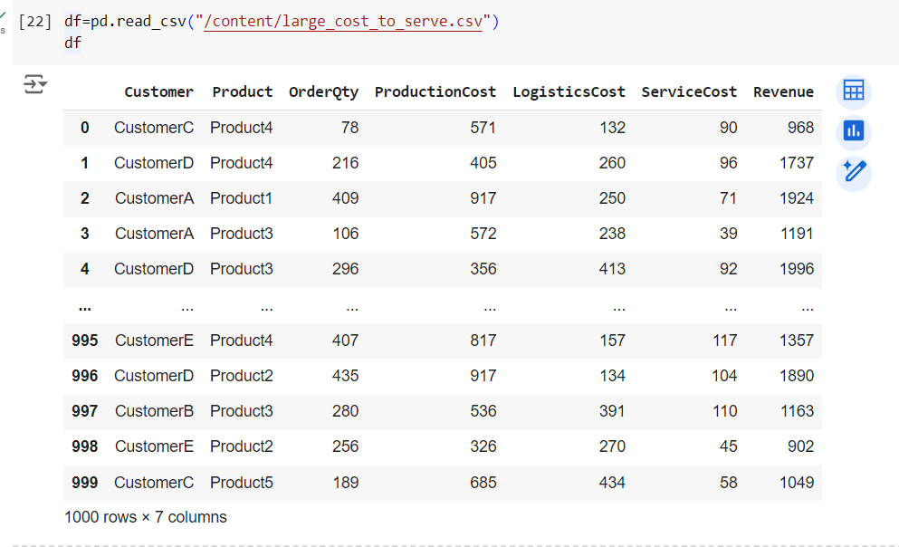

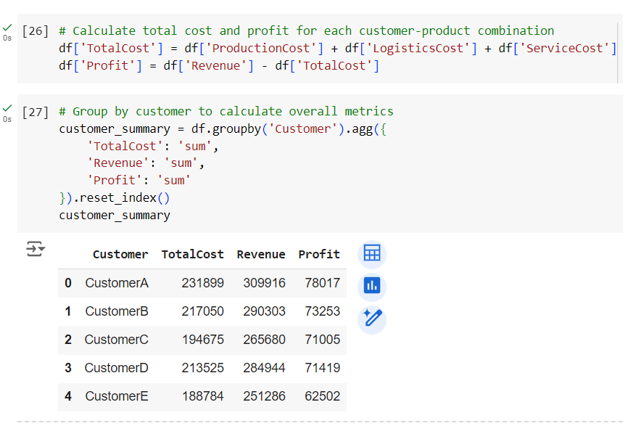

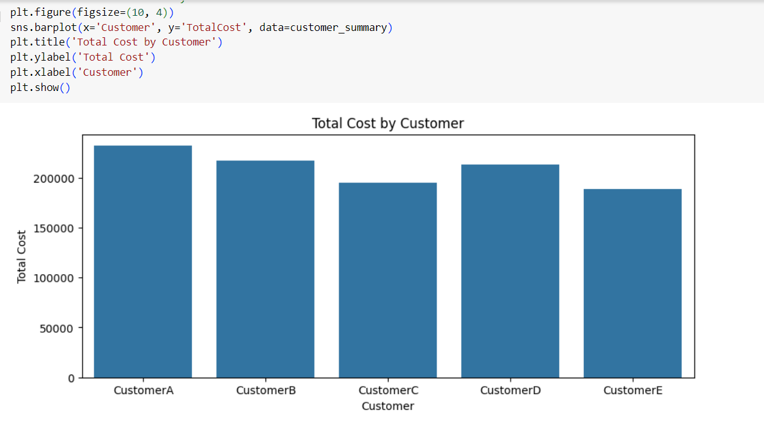

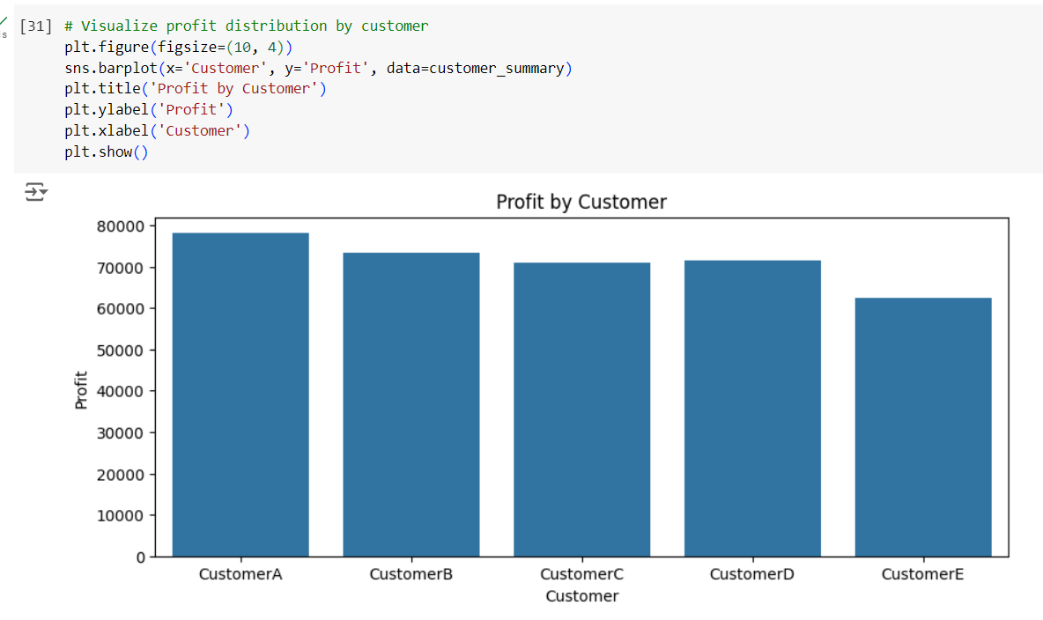

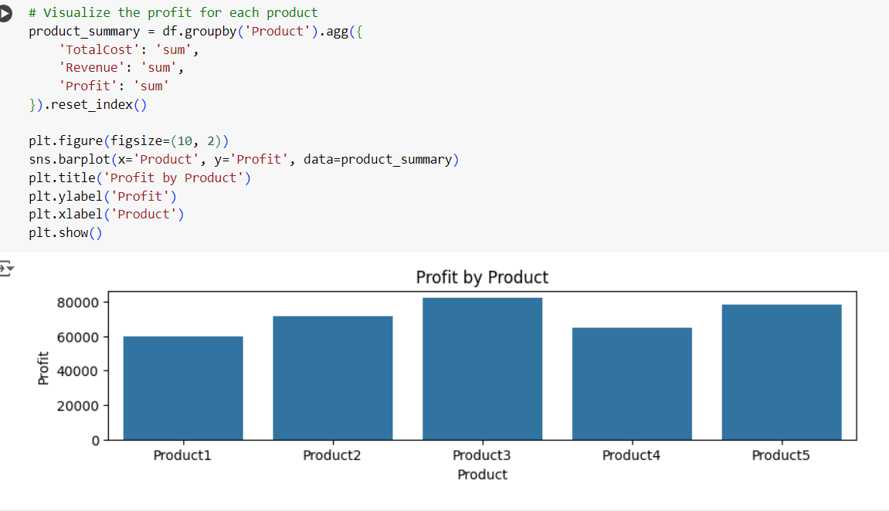

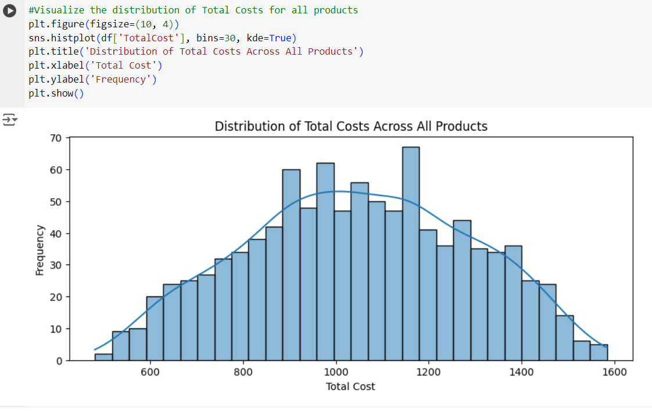

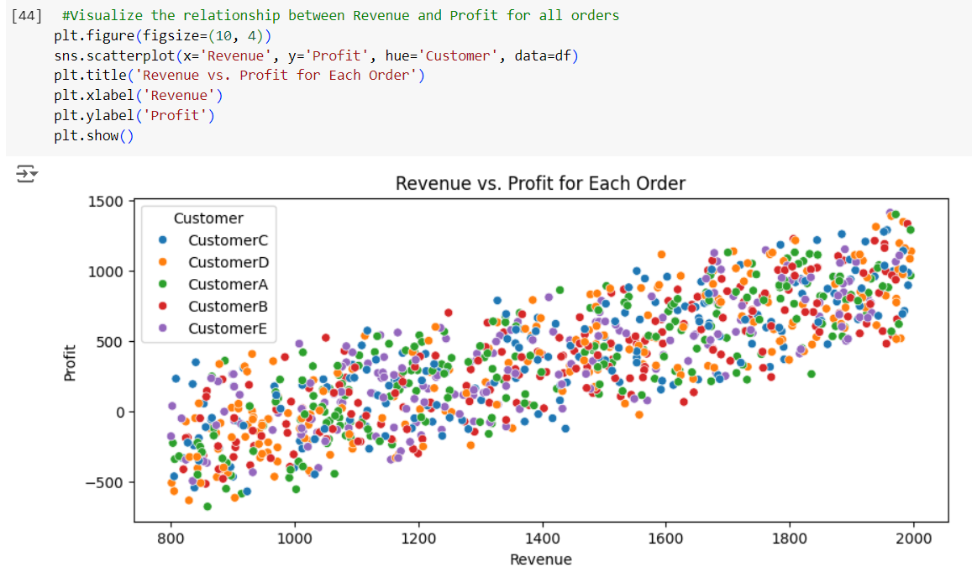

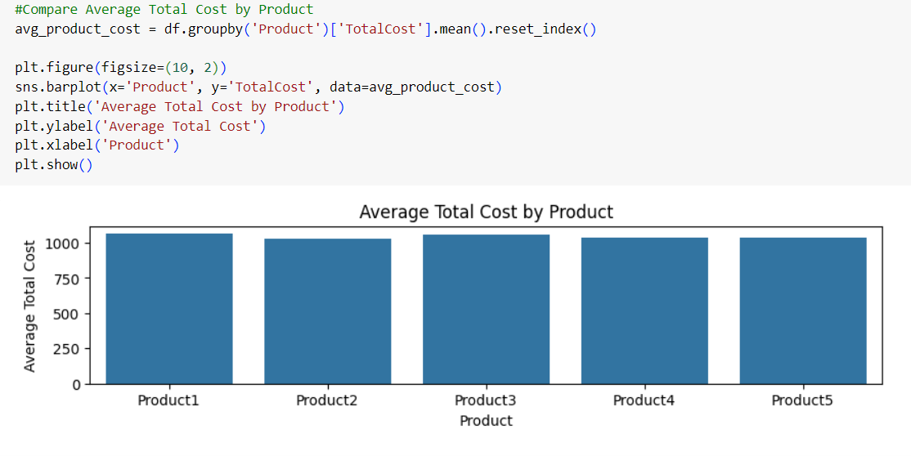

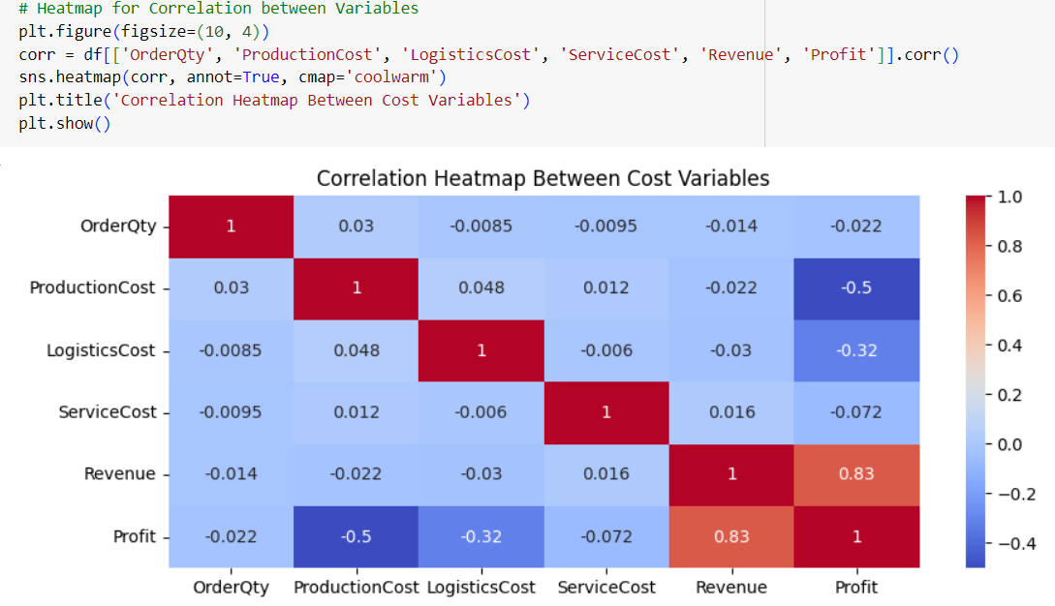

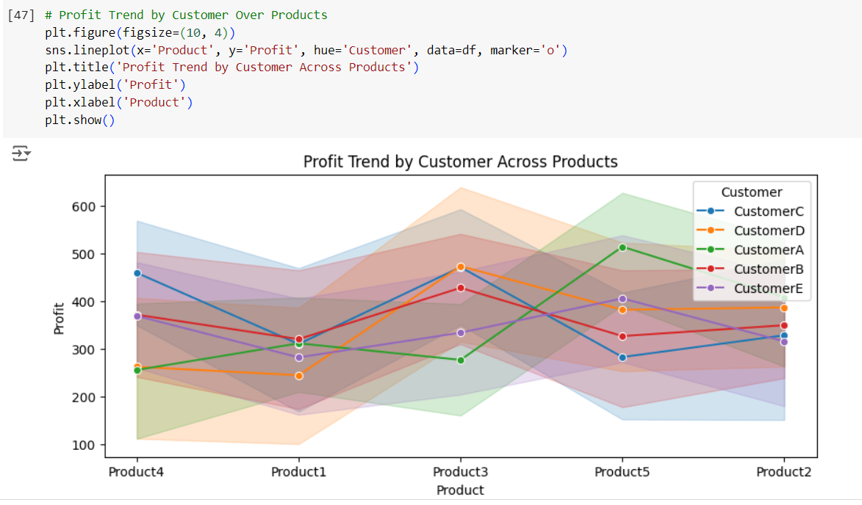

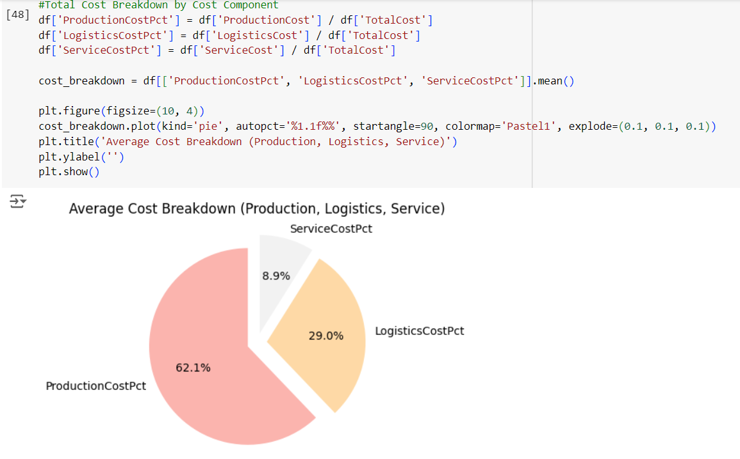

**Progress**

* **Accomplishments:**

1. Improved Cost Transparency: Identified detailed breakdowns of production, logistics, and service costs for each customer and product.
2. Profitability Insights: Analyzed profit margins across customers and products, highlighting underperforming areas.
3. Data-Driven Decision Making: Provided actionable insights into cost drivers and profitability trends, aiding in strategic planning.
4. Enhanced Visual Reporting: Created clear and impactful visualizations for better understanding of cost and profit distribution.
5. Correlation Analysis: Revealed key relationships between costs, order quantities, revenue, and profit, guiding cost optimization efforts.

* **Metrics:**

1. Total Cost per Customer: Sum of production, logistics, and service costs for each customer.
2. Profit Margin: (Revenue - Total Cost) / Revenue, showing profitability across customers and products.
3. Cost Breakdown Percentage: Percentage contribution of production, logistics, and service costs to the total cost.
4. Revenue per Product: Total revenue generated by each product.
5. Cost-to-Revenue Ratio: Total cost divided by revenue, indicating cost efficiency.

**Challenges and Solutions**

* **Challenges Faced:**

1. Data Complexity: Managing and integrating data from multiple sources like production, logistics, and customer service.
2. Cost Allocation: Accurately assigning indirect costs to specific customers or products.
3. Scalability Issues: Handling large datasets and scaling analysis for growing operations.
4. Profitability Misalignment: Difficulty in identifying hidden cost drivers that reduce profitability.

* **Solutions Implemented:**

1. Data Integration Tools: Use automated tools to merge and clean data from various systems (ERP, CRM, etc.).
2. Cost Allocation Models: Implement advanced allocation methods, such as activity-based costing, to improve accuracy.
3. Big Data Capabilities: Leverage scalable tools like cloud-based platforms and optimized queries for large datasets.
4. Profitability Analysis: Use detailed cost breakdowns and visualizations to uncover hidden inefficiencies.

**Next Steps**

* **Upcoming Tasks:** To face upcoming tasks in the manufacturing sector, focus on advanced analytics, data management, automation, real-time monitoring, and cross-functional collaboration.
* **Goals:** To achieve upcoming goals, prioritize data-driven decision-making, continuous process optimization, and strategic collaboration across teams.

**Conclusion**

* **Summary:** The Cost to Serve (CTS) analysis in the manufacturing sector provides critical insights into cost structures and profitability, enabling informed decision-making. By addressing challenges and leveraging data-driven strategies, organizations can optimize costs and enhance overall efficiency.
* **Acknowledgments:** Thank you all for your attention and engagement, I appreciate your interest in the Cost to Serve analysis.